Farmogram

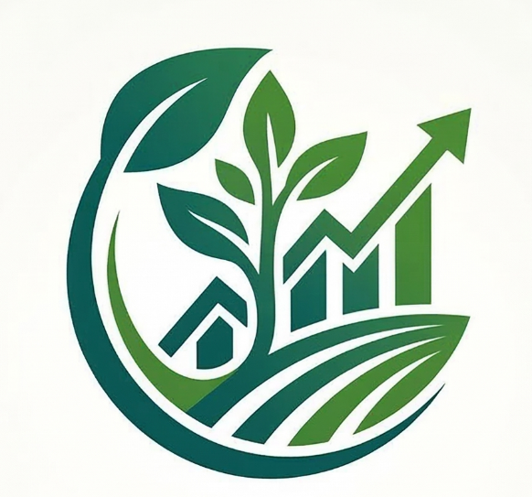

(Smart AgroConnect & Management System)

Abstract :

Agriculture is an important part of the economy, but many farmers face problems such as low profits, lack of direct market access, and dependency on middlemen. Because of these intermediaries, farmers often receive less income for their crops, while buyers do not always get clear information about the source of the produce. Many digital platforms also fail to help rural farmers because they are difficult to use and do not support regional languages.
Farmogram is a web-based agricultural platform designed to connect farmers directly with buyers and improve the agricultural supply system. The platform allows farmers to sell their crops directly to retailers and wholesalers without the involvement of middlemen. It also includes a pre-booking feature where buyers can pay an advance amount to reserve crops before harvest, which helps farmers receive early financial support during the crop-growing period.
The system also provides a real-time messaging feature that allows farmers and buyers to communicate easily and negotiate prices. To make the platform accessible to more users, Farmogram supports multiple languages so farmers can use the system in their preferred language.
In addition, the platform includes smart features such as weather updates, crop identification using image scanning, and an AI-based assistant that provides farming guidance. These features help farmers make better decisions and improve crop productivity.
Overall, Farmogram helps farmers become more independent by providing direct market access, useful farming information, and modern digital tools, while buyers benefit from better transparency and easier crop purchasing.

1. Introduction

Farmogram is a smart web-based agricultural support system designed to help farmers manage their farming activities more efficiently using modern web technologies. The system provides farmers with useful information such as weather updates, crop market prices, crop performance insights, and direct communication features.
The platform connects farmers, buyers, and administrators in a single digital system where farmers can monitor their crops, check market trends, and sell their agricultural products. The system also includes intelligent features like a smart assistant and weather forecasting that help farmers make better farming decisions.
Farmogram is an advanced, real-time Agritech B2B (Business-to-Business) marketplace built to solve these systemic issues. It operates as a comprehensive digital ecosystem that bridges the gap between rural agriculture and modern supply chains. By utilizing a direct peer-to-peer negotiation engine, Farmogram completely eliminates intermediaries. It introduces a revolutionary 20% Pre-Booking Smart Contract system, allowing buyers to secure future harvests while providing farmers with immediate working capital. Designed with rural accessibility in mind, the platform integrates seamless phone-based authentication, a real-time multi-lingual translation engine supporting over 9 regional languages, and cross-platform push notifications to keep logistics moving instantly.
The main goal of this project is to digitize agricultural information and services so that farmers can access important data quickly and improve productivity, profitability, and decision-making in farming.

1.1 Objectives

The primary goal of Farmogram is to digitize, democratize, and streamline the agricultural supply chain. The specific objectives of this project are:
- To Eliminate Intermediaries: Build a direct B2B marketplace that connects verified farmers straight to retail buyers, ensuring farmers receive 100% of the negotiated crop value while lowering procurement costs for buyers.
- To Provide Financial Security for Farmers: Implement a "Growing Crop" pre-booking system that allows buyers to pay a 20% advance contract fee, injecting crucial working capital directly into the farmer's hands before the harvest is even complete.
- To Facilitate Transparent Negotiations: Develop a real-time, WhatsApp-style messaging interface where buyers and farmers can discuss crop quality, negotiate bulk pricing, and generate secure "Custom Offers" that sync directly to the checkout cart.
- To Ensure Rural Accessibility: Break down the digital divide by implementing mobile-number-based login (removing the reliance on email) and integrating a Google Neural Translation Engine so the entire dashboard can be instantly used in regional languages (Hindi, Marathi, Kannada, Tamil, etc.).
- To Streamline Logistics & Tracking: Create a modern, Kanban-style order management system powered by real-time OneSignal Web Push Notifications, ensuring both parties receive instant alerts when payments are made, or shipments are dispatched.

1.2 Problem Statement

- Dependence on Middlemen
Farmers often rely on brokers and intermediaries to sell their crops, which reduces the profit they receive.
- Low Income for Farmers
A large portion of the profit goes to middlemen, leaving farmers with very little financial return.
- Lack of Financial Support During Crop Growth
Farmers need money for seeds, fertilizers, and equipment during the growing season but only earn income after selling their crops.
- Language Barrier in Digital Platforms
Many agricultural platforms are available only in English, making it difficult for rural farmers who prefer regional languages.
- Lack of Direct Connection Between Farmers and Buyers
Farmers and buyers cannot easily communicate or negotiate prices directly.
- Unpredictable Market Prices
Buyers and farmers often face uncertainty in crop prices due to lack of transparency in the supply chain.
- Limited Access to Agricultural Information
Farmers do not always have easy access to useful information such as weather updates, crop advice, or market prices.

1.3 Applications :

- Direct Agricultural Marketplace
Farmogram connects farmers directly with buyers and wholesalers, allowing them to sell crops without middlemen and get better profits.

- Advance Crop Booking System
Buyers can book crops before harvest by paying an advance amount, which helps farmers get financial support during the crop-growing period.

- AI-Based Farming Assistance
The platform provides an AI chatbot that helps farmers with farming advice, fertilizer suggestions, and solutions to agricultural problems.

- Crop Identification System
Farmers can upload photos of plant leaves or crops, and the system identifies the crop type.

- Order and Delivery Tracking
Buyers can track their crop orders from processing to delivery, improving transparency in the supply chain.

- Farmer–Buyer Communication System
A messaging feature allows farmers and buyers to communicate directly and negotiate crop prices easily.

- Agricultural Scheme and Language Support
The system supports multiple regional languages and helps farmers learn about government agricultural schemes.

- Farm Data and Sales Management
Farmers can manage crop performance, track sales history, generate invoices, and analyze profits using the system.

2. Outcomes :

- Financial Empowerment for Farmers
Farmogram allows farmers to sell crops directly to buyers without middlemen, helping them earn better profits and reducing extra commission costs.

- Financial Support Before Harvest
The pre-booking feature allows buyers to pay an advance amount for crops, giving farmers financial support during the crop growing stage.

- Improved Crop Management
The AI assistant and crop identification system help farmers detect crop diseases, identify pests, and get farming advice quickly, which can reduce crop loss.

- Easy Access for Rural Farmers
The platform supports multiple regional languages, making it easier for farmers to use the system even if they are not comfortable with English.

- Faster Disaster Support and Claims
Farmers can upload documents and images to report crop damage due to floods, pests, or drought, making it easier to process insurance or support claims.

- Improved Communication Between Farmers and Buyers
The messaging system allows farmers and buyers to communicate directly, negotiate prices, and manage orders efficiently.

- Better Farm Data Management
The system stores crop information, sales history, and performance data, helping farmers analyze profits and improve their farming practices.

